1. **Requirement**

Client:

* 1. Normal visitors have no access to content of the application. What they can access is the function of Log in or Register.
  2. All the functions are for members registered in the application
     1. **Patient**

Most patients are university students:

1. They want to consult doctors some issues on their health online.
2. They want to get prompt medical aid in a more efficient and effective way.
3. They want to understand relevant knowledge for preventing occurrences of some common or serious diseases via a normal and authoritative channel.
4. They want to manage their personal information.
   * 1. **Doctor**
5. They want to offer healthy assistances to patients as much as possible.
6. They want to communicate with other doctors, especially those medical experts as much as possible via multiple ways, like instant communication, video communication and shared meeting room.
7. They want to acquire some latest news, information and theses about medicine via an authoritative channel for making them enrich and realize the development of medical research.
8. They want to manage their personal information.
   * 1. **Administrator**

1. They want to manage users (patient, doctor) data (account, password, gender, phone number….) in a reasonable and convenient way, such as automated monitor, automated log report, formatted table, Hierarchical file and remote access/ management.

2. They want to use some online tools to help them manage feedback from users (patient, doctor) and recommended articles, such as Excel, Quick search, template and automated storage / backup.

Mobile:

* 1. App
     1. Normal visitors fail to access anything in the system, except the function of log in/ Register
     2. All the functions are for member registered in the application
        1. **Patient**

The functions patients can use via the App:

|  |  |
| --- | --- |
| **Functions** | **Explanations** |
| Search for symptoms | Searching medical resources according to symptoms |
| News feed | Health tips and hot news about health care |
| Self diagnosis | Searching health care for users’disease |
| Hot topics | Showing recent hot topics and people’s comments |
| Latest Articles | Showing latest articles |
| Hot articles | Showing hot articles |
| Departments | Classification of hospital’s departments |
| Personal information | 1. setting nickname 2. showing account number, gender, distinct, address and university |
| My doctor | Showing doctors users follow |
| My news | Showing users interested news |
| Setting and Help | 1. Managing notifications 2. Modifying password 3. Rating for the App 4. Updating App 5. Help 6. Statements of app |
| Feedback | Feedback |
| Doctor | 1. Doctors’relevant information 2. Communication with doctor 3. Comments to the doctor |
| Articles | 1. Articles list 2. Rating, Comments, Complaints |
| Chatting | Intsantly chatting with doctor |

* + - 1. **Doctor**

The functions doctors can use via the App:

|  |  |
| --- | --- |
| **Functions** | Explanations |
| Latest articles | Latest articles |
| Hot topics | Hot topics |
| Communications | Recent logs of chattings with patents |
| Personal information | Head portiat, account number, gender,distinct, hospital, position |
| Setting and Help | * 1. Managing notifications   2. Modifying password   3. Rating for App  1. Help 2. Updating App 3. Statements |
| Feedback | Feedback |

* + - 1. **Administrator**

The functions administrator can use via the App:

|  |  |
| --- | --- |
| **Functions** | Explanations |
| Article management | Articles lists with modification options |
| Feedback | Feedback received from users |
| Doctor management | 1. Insert doctor 2. Doctor lists |
| Topic aide | * 1. Issue a topic   2. Push healthy tips |
| Administrator | 1. Log off: exit current account 2. Modify current password |
| Search | Search other functions |

1. **System**
   1. **Mobile-App**
      1. **patient pages: (UI)**
         1. **Login page**

Three parts in the page:

1) Status bar

2) Navigation bar

3) content

The Status bar includes network signal, battery situation, current time......

The Navigation bar has a page title called "User Login".

The content consists of four parallel content bars with different functions:

1) First row includes an image of man followed by an input field with hints “please enter account”.

2) Second row has an image of lock, followed by an input field with hints “Please enter password”.

3) Third row consists of a button with green of background color and text “Login”.

4) Final row covers two buttons with name of “Quick registration”,” Forgotten password” respectively in left and right side.

Considering almost every interviewee is sensitive to their personal information and observing some popular applications of assistance in market, the content in the input field with password shows implicitly to user. Besides, the initial main style of color is green after

discussed with teammates due to green color gives individuals a feeling of peace and comfortable that may attract more users to use our app. Our team also use green as this application's main color.

Based on above evaluations, there is an initial mockup for login interface designed by balsamiq mockup and see figure Login.

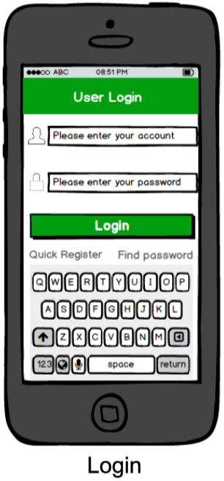

* + - 1. **Registration page**

Two parts in the page:

1) Status bar

2) Navigation bar

3) Content

The Status bar is as same as that in Login page.

The Navigation bar has a page title called "registration" and a return key.

The content consists of six parallel content bars with different functions:

1) a label named "phone number" followed by an input text with hints "please input correct phone number"

2) a label named "verified code" followed by an input text with hints "please input code you received". a button named "Acquire" is on the most

right side

3) a label named "Password" followed by an input text with hints “please enter password”

4) a label named "Confirm" followed by an input text with hints "please enter password again"

5) a check box followed by a text "I agree with user protocol"

6) a button named "Register Now"

Considering the security of our application and efficiency of the system, my team decide to take phone number as users' account number. Besides, to better manage the system, our team also need to verify the certification of phone number that users submit to registration via sending a verified code by phone number. What is more, to inform users better understand and use our system, our team provide user protocol for them.

Based on above evaluations, there is an initial mockup for registration interface designed by balsamiq mockup and see figure Register.

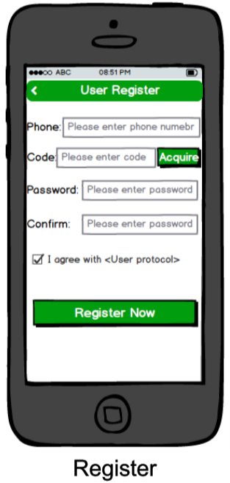

* + - 1. **Resetting password page**

The layout of this page is as same as Registration interface except the bottom button named as "Reset password".

Based on above evaluations, there is an initial mockup for Resetting password interface designed by balsamiq mockup and see Reset Password.

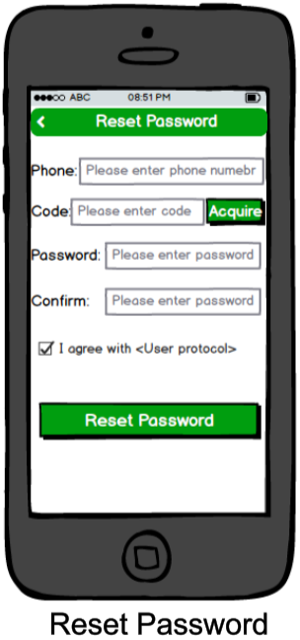

* + - 1. **Home page**

Three parts in the page:

1) Status bar

2) Content

3) Main menu bar

The Status bar is as same as that in Login page.

The content consists of four parallel content bars with different functions:

1) input text as a search bar for checking articles in the left side and a button with a picture bell for notification management (system message, messages from doctor…) in another side.

2) button named “self-diagnosis” in the left side and one named “life tips” for pushing relevant healthy knowledge, hot topics and others in another side.

3) A list with title “Hot topics” for reading the latest and hottest topics and give comments to a topic.

4) A list with title “Latest articles” for showing the latest three news to users.

Main menu bar consists three parts:

1) A button with picture house and name “Home” for showing the Home page.

2) A button with picture compass and named “Department” for guiding users select corresponding department based on their own symptom.

3) A button with picture man and named “Me” for users managing their own personal information.

Based on above evaluations, there is an initial mockup for Home page designed by balsamiq mockup and see figure Home.

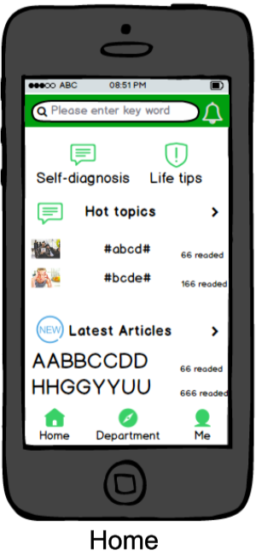

* + - 1. **Department page**

Three parts in the page:

1) Status bar

2) Navigation bar

3) Content

4) Main menu bar

The Status bar is as same as that in Login page.

The navigation bar has a label named “Department” in the medial and a button with a picture bell for notification management in the right side.

The content consists of eleven buttons with pictures of departments of hospital and name of each department below the picture, and it shows on the screen based on order of four buttons in each row.

The main menu bar is as same as that in Home page.

Based on above evaluations, there is an initial mockup for Department page designed by balsamiq mockup and see figure Department.

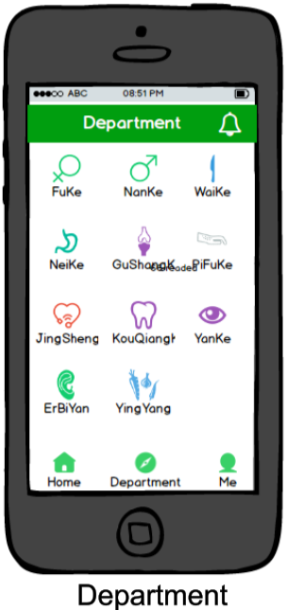

* + - 1. **Me Page**

Three parts in the page:

1) Status bar

2) Content

3) Maini menu bar

The Status bar is as same as that in Login page.

The content consists of six parallel content bars with different functions:

1. An image of user’s head portrait in the left, and a label of user’s nick name in the middle followed by a button with picture bell for notification management.
2. A label with name” My Doctors”, followed by a button of next arrow.
3. A label with name “News Collections” followed by a button of next indicator.
4. A label with name “Setting and Help” followed by a button of next indicator.
5. A label with name “Feedback” followed by a button of next indicator.
6. A label with name “Software Version number”.

The main menu bar is as same as that in Home page.

Based on above evaluations, there is an initial mockup for Me page designed by balsamiq mockup and see figure Me.

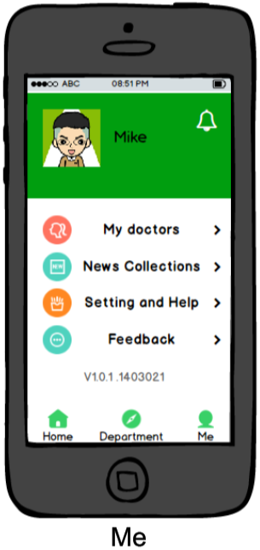

* + - 1. **Self-diagnosis page**

Three parts in the page:

1) Status bar

2) Navigation bar

3) Content

The Status bar is as same as that in Login page.

The navigation bar consists of a return button followed by a page label named “Self-diagnosis” in the middle of the bar.

The Content consists of two parallel content bars with different functions:

1. An input field with hints “Please enter symptoms”.
2. A label with name of “Potential causes to this symptom” followed by a list of causes that lead to this symptom.

Based on above evaluations, there is an initial mockup for Self-diagnosis page designed by balsamiq mockup and see figure self-diagnosis.

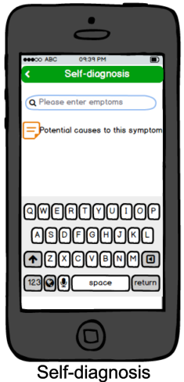

* + - 1. **Topic center page**

Three parts in the page:

1) Status bar

2) Navigation bar

3) Content

The Status bar is as same as that in Login page.

The navigation bar consists of a return button followed by a page label named “Topic center” in the middle of the bar.

The Content consists of a variable list in which each element of list includes an image of a topic in the left and a label of topic’s title in the middle, followed by another label of follower number in the end.

Based on above evaluations, there is an initial mockup for Topic center page designed by balsamiq mockup and see figure topic center.

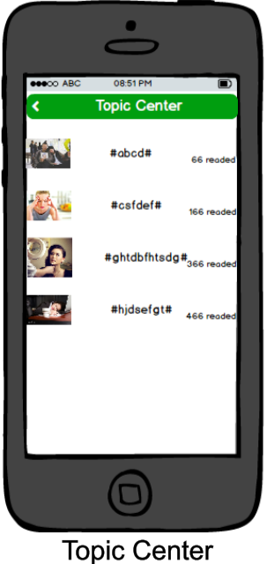

* + - 1. **Topic page**

Three parts in the page:

1) Status bar

2) Navigation bar

3) Content

The Status bar is as same as that in Login page.

The navigation bar consists of a return button followed by a page label named “Topic” in the middle of the bar.

The Content consists of two parts:

1) An image of a topic in the left side, and a label of topic title, a button with name of “Follow”, followed by a brief introduction of this topic.

2) A variable list of users’ comments in which each element of list includes user’s head portrait, users’ nick name and users’ university.

Based on above evaluations, there is an initial mockup for Topic page designed by balsamiq mockup and see figure topic.

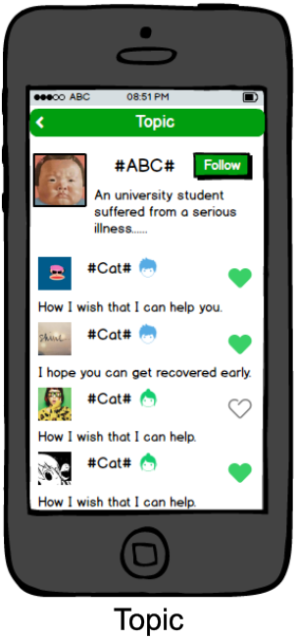

* + - 1. **Latest Articles page**

Three parts in the page

1) Status bar

2) Navigation bar

3) Content

The Status bar is as same as that in Login page.

The navigation bar consists of a return button followed by a page label named “Article List” in the middle of the bar

The Content consists of a variable list of all latest articles in which each element of the list includes a label of article’s title, followed by another label of number of readers.

Based on above evaluations, there is an initial mockup for Article List page designed by balsamiq mockup and see figure Article List.

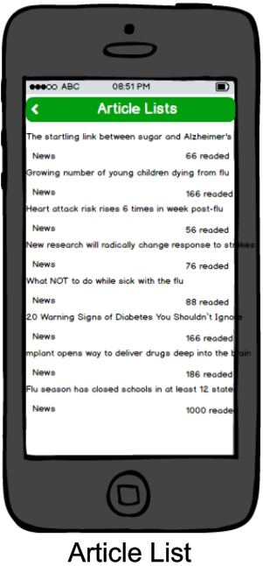

* + - 1. **Article page**

Three parts in the page:

1) Status bar

2) Navigation bar

3) Content

The Status bar is as same as that in Login page.

The navigation bar consists of a return button followed by a page label named “Article” in the middle of the bar

The Content consists of three parallel content bars:

1) A label of the article’s title.

2) A label for displaying the time of the publication of this article, followed by another label for showing news’ source location.

3) A text area for showing the content of the article.

Based on above evaluations, there is an initial mockup for Article page designed by balsamiq mockup and see figure Article.

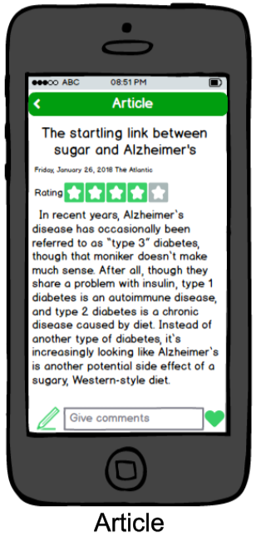

* + - 1. **Doctor list page**

Three parts in the page:

1) Status bar

2) Navigation bar

3) Content

The Status bar is as same as that in Login page.

The navigation bar consists of a return button followed by a page label named “Department” in the middle of the bar.

The Content consists of a variable list of doctors from different hospitals, in which each element of list includes the image of the doctor and his/her name, work place and duties.

Based on above evaluations, there is an initial mockup for Doctor List page designed by balsamiq mockup and see figure Doctor List.

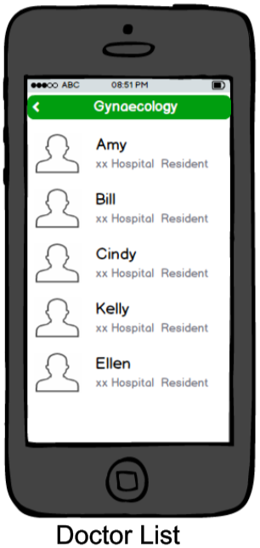

* + - 1. **Doctor page**

Three parts in the page:

1) Status bar

2) Navigation bar

3) Content

The Status bar is as same as that in Login page.

The navigation bar consists of a return button followed by a page label named “Doctor” in the middle of the bar.

The Content consists of two parts:

1. An image of doctor in the left, and a label of doctor’s name, work place, duties, followed by two buttons named “Follow” and “Chatting”.
2. A variable list of all comments from patients.

Based on above evaluations, there is an initial mockup for Doctor page designed by balsamiq mockup and see figure Doctor.

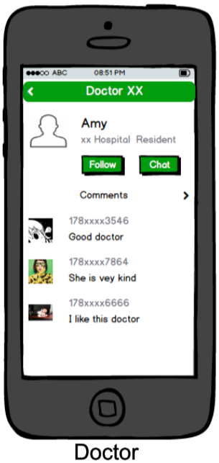

* + - 1. **Personal information page**

Three parts in the page:

1) Status bar

2) Navigation bar

3) Content

The Status bar is as same as that in Login page.

The navigation bar consists of a return button followed by a page label named “Personal Information” in the middle of the bar.

The Content consists of Seven parallel content bars of different functions:

1. A label named “Head portrait”, followed by an image of user’s head portrait.
2. A label named “Nick name”, followed by a text with User’s nick name.
3. A label named “Account”, followed by a label user’s phone number.
4. A label named “Gender”, followed by a text with user’s gender.
5. A label named “Distinct”, followed by a text with user’s distinct.
6. A label named “Address”, followed by a text with user’s address.
7. A label named “School”, followed by a text with user’s school.

Based on above evaluations, there is an initial mockup for Personal information page designed by balsamiq mockup and see figure Personal Information.

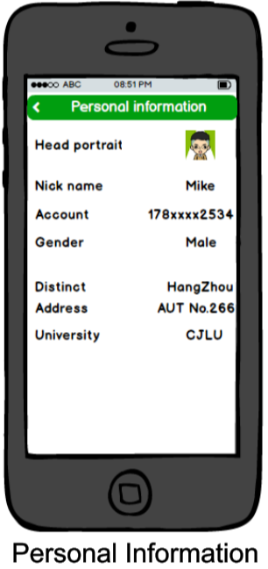

* + - 1. **Feedback page**

Three parts in the page:

1) Status bar

2) Navigation bar

3) Content

The Status bar is as same as that in Login page.

The navigation bar consists of a return button followed by a page label named “Feedback” in the middle of the bar.

The Content consists of three parts:

1. A label named “We concern about your suggestions, please give us your opinion:”
2. A blank text field for users to write down their opinion.
3. A button named “Submit”.

Based on above evaluations, there is an initial mockup for Feedback page designed by balsamiq mockup and see figure Feedback.

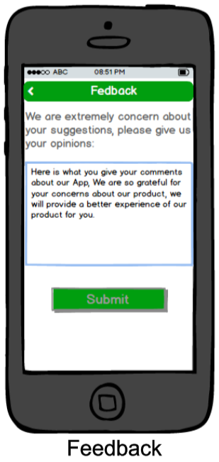

* + - 1. **Setting and Help**

Three parts in the page:

1. Status bar
2. Navigation bar
3. Content

The Status bar is as same as that in Login page.

The navigation bar consists of a return button followed by a page label named “Setting and Help” in the middle of the bar.

The Content consists of Seven parallel content bars of different functions:

1. A label named “Notification”, followed by a button with next arrow.
2. A label named “Modify password”, followed by a button with next arrow.
3. A label named “Rate for the App”, followed by a button with next arrow.
4. A label named “Update”, followed by a button with next arrow.
5. A label named “Help”, followed by a button with next arrow.
6. A label named “Statement”, followed by a button with next arrow.
7. A button “Log off”.

Based on above evaluations, there is an initial mockup for Setting and Help page designed by balsamiq mockup and see figure Setting and Help.

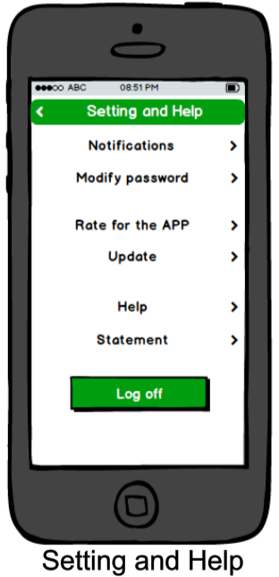

* + - 1. **My Doctors page**

The layout is as same as that in Doctor list page and see figure my doctors.

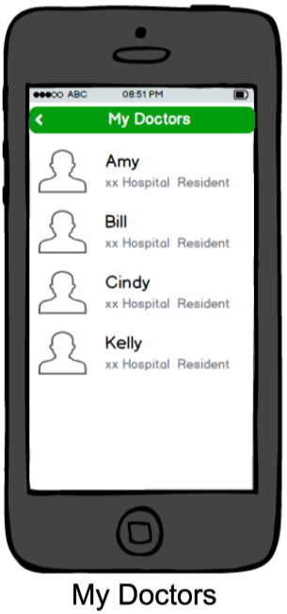

* + - 1. **News Collections**

The layout is as same as that in Latest Articles page and see figure news collections.

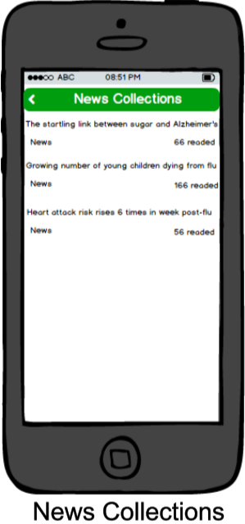

* + 1. **Doctor page: (UI)**
       1. **Login page**

The layout in the page is as same as that in Login page in patient, However, to ensure the reliability and profession of medical staff served for patients, Users have no authority to register for a doctor, only administrator can add doctor’s registration information and give relevant privileges to the doctor, there is no button named “Register” in the page compared with that in patient’s login page.

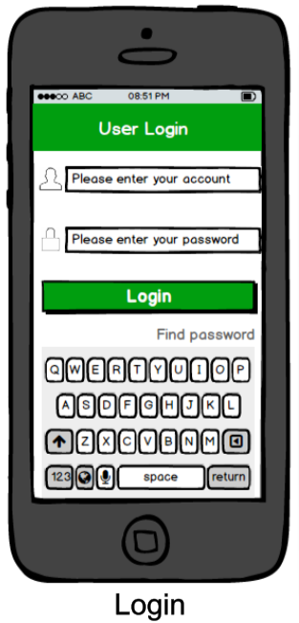

* + - 1. **Home page**

Three parts in the page:

1) Status bar

2) Content

3) Main menu bar

The Status bar is as same as that in Login page.

The content consists of three parallel content bars with different functions:

1) An input text as a search bar for checking articles in the left side and a button with an image of bell for notification management (system message, messages from doctor…) in another side.

2) A list with title “Hot topics” for reading the latest and hottest topics and give comments to a topic, in which each element of list includes an image of a topic in the left and a label of topic’s title in the middle, followed by another label of follower number in the right end.

3) A list with title “Latest articles” for showing the latest three news to users, in which each element of the list includes a label of article’s title, followed by another label of number of readers.

Main menu bar consists three parts:

1) A button with picture house and name “Home” for showing the Home page.

2) A button with picture compass and named “Communication” for guiding users select corresponding department based on their own symptom.

3) A button with picture man and named “Me” for users managing their own personal information.

Based on above evaluations, there is an initial mockup for Home page designed by balsamiq mockup and see figure Home.



* + - 1. **Communication list**

There are four parts in the page:

1) Status bar

2) Navigation bar

3) Content

4) Main menu bar

The Status bar is as same as that in Login page.

The navigation bar consists of a return button followed by a page label named “Communication list” in the middle of the bar.

The Content consists of a variable list of patients that communicate with doctors, in which each element of the list includes an image of patients’ head portrait, a label with name of the patient, followed by a label for showing last date and time of communication.

The main menu bar is as same as that in Home page.

Based on above evaluations, there is an initial mockup for Communication list page designed by balsamiq mockup and see figure Communication list.

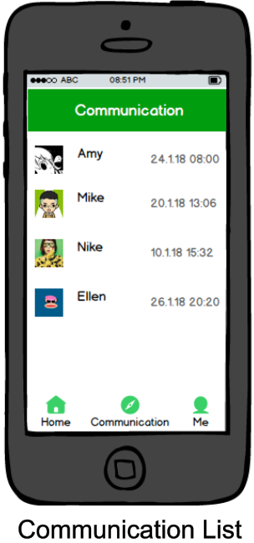

* + - 1. **Me page**

Three parts in the page:

1) Status bar

2) Content

3) Maini menu bar

The Status bar is as same as that in Login page.

The content consists of five parallel content bars with different functions:

1. An image of user’s head portrait in the left, and a label of user’s nick name in the middle followed by a button with picture bell for notification management.
2. A label with name “News Collections” followed by a button of next indicator.
3. A label with name “Setting and Help” followed by a button of next indicator.
4. A label with name “Feedback” followed by a button of next indicator.
5. A label with name “Software Version number”.

The main menu bar is as same as that in Home page.

Based on above evaluations, there is an initial mockup for Me page designed by balsamiq mockup and see figure Me.

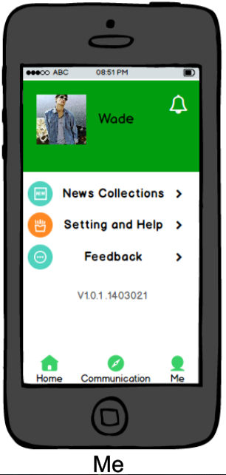

* + - 1. **Personal Information page**

The layout is as same as that in personal information page of patient.

* + - 1. **Setting and Help**

The layout is as same as that in Setting and Help page of patient.

* + 1. **Database:**

TABLE `article` (

`id` int (5) NOT NULL auto_increment,

`name` varchar (100) character set utf8 default NULL,

`source` varchar (40) character set utf8 default NULL,

`date` varchar (10) character set utf8 default NULL,

`article` varchar (10000) character set utf8 default NULL,

`click` int (10) default NULL,

`kind` varchar (50) character set utf8 default NULL,

`token` varchar (50) default NULL,

`comment` varchar (250) character set utf8 default NULL,

PRIMARY KEY (`id`)

) ENGINE=InnoDB DEFAULT CHARSET=latin1;

TABLE `article_collection` (

`title` varchar (255) character set utf8 NOT NULL,

`date` varchar (255) character set utf8 default NULL,

`source` varchar (255) character set utf8 default NULL,

`kind` varchar (255) character set utf8 default NULL,

`article` varchar (255) character set utf8 default NULL,

`comment` varchar (255) character set utf8 default NULL,

`token` varchar (255) character set utf8 NOT NULL,

`id` int (11) NOT NULL

) ENGINE=InnoDB DEFAULT CHARSET=latin1;

TABLE `collection` (

`token_user` varchar (50) default NULL,

`token_article` varchar (50) NOT NULL,

`title` varchar (50) default NULL,

PRIMARY KEY (`token_article`)

) ENGINE=InnoDB DEFAULT CHARSET=latin1;

TABLE `departi` (

`s_depid` int (5) default NULL,

`s_aid` int (5) default NULL

) ENGINE=InnoDB DEFAULT CHARSET=latin1;

TABLE `department` (

`depid` int(5) NOT NULL auto_increment,

`name` varchar (100) character set utf8 default NULL,

PRIMARY KEY (`depid`)

) ENGINE=InnoDB AUTO_INCREMENT=56 DEFAULT CHARSET=latin1;

TABLE `depdis` (

`s_id` int (5) default NULL,

`s_disid` int (5) default NULL

) ENGINE=InnoDB DEFAULT CHARSET=latin1;

TABLE `disarti` (

`s_disid` int (5) default NULL,

`s_aid` int (5) default NULL

) ENGINE=InnoDB DEFAULT CHARSET=latin1;

TABLE `disease` (

`id` int(11) NOT NULL auto_increment,

`name` varchar (100) character set utf8 default NULL,

`intro` varchar (1000) character set utf8 default NULL,

`part` varchar (50) character set utf8 default NULL,

`cause` varchar (5000) character set utf8 default NULL,

`prevent` varchar (5000) character set utf8 default NULL,

`nurse` varchar (5000) character set utf8 default NULL,

`click` int (10) default NULL,

PRIMARY KEY (`id`)

)

TABLE `doc_collection` (

`head` varchar (255) character set utf8 default NULL,

`phone` varchar (255) character set utf8 default NULL,

`name` varchar (255) character set utf8 default NULL,

`hospital` varchar (255) character set utf8 default NULL,

`department` varchar (255) character set utf8 default NULL,

`position` varchar (255) character set utf8 default NULL,

`sex` varchar (5) character set utf8 default NULL,

`area` varchar (255) character set utf8 default NULL,

`token` varchar (255) character set utf8 default NULL

)

TABLE `guide` (

`name` varchar (100) character set utf8 default NULL,

`time` varchar (50) character set utf8 default NULL,

`fre` varchar (50) character set utf8 default NULL,

`pre` varchar (100) character set utf8 default NULL,

`pro` varchar (1000) character set utf8 default NULL,

`sta` varchar (1000) character set utf8 default NULL

)

TABLE `ofchatlogs` (

`MESSAGEID` int (11) NOT NULL,

`SESSIONJID` varchar (30) character set utf8 collate utf8_unicode_ci default NULL,

`SENDER` varchar (30) character set utf8 default NULL,

`RECEIVER` varchar (30) character set utf8 default NULL,

`CREATEDATE` varchar (30) default NULL,

`LENGTH` int (11) default NULL,

`CONTENT` varchar (255) character set utf8 default NULL,

`DETAIL` varchar (255) character set utf8 default NULL,

`STATE` int (11) default NULL

)

TABLE `ofuser` (

`username` varchar (64) NOT NULL,

`storedKey` varchar (32) default NULL,

`serverKey` varchar (32) default NULL,

`salt` varchar (32) default NULL,

`iterations` int (11) default NULL,

`plainPassword` varchar (32) default NULL,

`encryptedPassword` varchar (255) default NULL,

`name` varchar (100) default NULL,

`email` varchar (100) default NULL,

`creationDate` char (15) default NULL,

`modificationDate` char (15) default NULL,

PRIMARY KEY (`username`)

)

TABLE `symarti` (

`s_sid` int (5) default NULL,

`s_aid` int (5) default NULL

)

TABLE `symdis` (

`s_id` int (5) default NULL,

`s_disid` int (5) default NULL

)

TABLE `symptom` (

`symid` int (5) NOT NULL auto_increment,

`name` varchar (100) character set utf8 default NULL,

PRIMARY KEY (`symid`)

)

TABLE `tab_comment` (

`head` varchar (255) character set utf8 default NULL,

`phone` varchar (255) character set utf8 default NULL,

`content` varchar (255) character set utf8 default NULL,

`token` varchar (255) character set utf8 NOT NULL,

`id` int (11) NOT NULL,

`date` varchar (50) character set utf8 default NULL

)

TABLE `tab_doc` (

`phone` varchar (20) character set utf8 default NULL,

`password` varchar (50) default NULL,

`name` varchar (20) character set utf8 NOT NULL,

`hospital` varchar (20) character set utf8 default NULL,

`department` varchar (20) character set utf8 default NULL,

`position` varchar (20) character set utf8 default NULL,

`sex` varchar (50) character set utf8 default NULL,

`area` varchar (50) character set utf8 default NULL,

`token` varchar (255) character set utf8 NOT NULL,

`state` int (5) default NULL,

PRIMARY KEY (`token`)

)

TABLE `tab_judge` (

`head` varchar (255) character set utf8 default NULL,

`phone` varchar (255) character set utf8 default NULL,

`content` varchar (255) character set utf8 default NULL,

`date` varchar (255) character set utf8 default NULL,

`token` varchar (255) character set utf8 NOT NULL,

PRIMARY KEY (`token`)

)

TABLE `tab_list_article` (

`title` varchar (30) character set utf8 NOT NULL,

`kind` varchar (30) character set utf8 default NULL,

`browse` int (30) default NULL,

`id` int (30) default NULL,

`date` varchar (50) character set utf8 default NULL

)

TABLE `tab_user` (

`phone` varchar (20) character set utf8 NOT NULL,

`password` varchar (30) character set utf8 NOT NULL,

`nickname` varchar (12) character set utf8 NOT NULL,

`sex` varchar (2) character set utf8 default NULL,

`area` varchar (50) character set utf8 default NULL,

`address` varchar (50) character set utf8 default NULL,

`school` varchar (50) character set utf8 default NULL,

`token` varchar (30) character set utf8 NOT NULL,

`head` varchar (255) character set utf8 default NULL,

`content` longtext character set utf8,

`encryptedPassword` varchar (50) default NULL,

`email` varchar (50) default NULL,

`createdate` datetime default NULL,

`modificationDate` datetime default NULL,

PRIMARY KEY (`phone`)

)

1. User Manual
2. Test_report